Sample Execution:

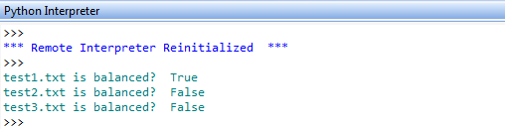

Analysis & Conclusion:

The program uses custom written stack class to check parenthesis balance. The stack class utilizes python list to serve as LIFO. File input is used to populate stack object.

The program currently reads input file character by character and pushes into stack only if it’s a parenthesis, curly brace or square bracket. Then it checks for balance.

By modifying the program a little, it is possible to check for quote or relational symbol (<>) balance.

The program was helpful to understand and utilize stack operations.